In The Name of Christ We Welcome You
May those who sorrow, find comfort; the weary, rest;
the troubled, peace; the unhappy, joy; the stranger, friends;
and may all find the sense of God’s presence in this holy place.

We’re glad that you are here. If you are a visitor, we want to greet you and get to know you. If you have not done so, please sign the Guest Book. After the Sunday services, please join us for refreshments in Julian Hall. Whether you are looking for a church home or just passing through, we would be glad to tell you more about…


A Pet-Friendly Mission of the Episcopal Diocese of San Diego

Mission Statement
To share Christ’s life-changing love with all people, invite and welcome them into the Body of Christ, and equip them for worship, ministry, and service.

*** Thank you for silencing your electronic devices ***

THE fourth SUNDAY after the epiphany:
Year C
Saturday, January 30, 2016  5:00 pm
Sunday, January 31, 2016  8:00 am & 10:15 am
5:00 pm – The Holy Eucharist: rite two
“BCP” refers to the Book of Common Prayer 1979—the red book.

The ringing of the bell signals that our worship is about to begin.
Please stand as you are able.

The Word of God
The Opening Acclamation BCP, p. 355
The Collect for Purity
The Song of Praise: Glory to God BCP, p. 356
The Collect of the Day BCP, p. 215
The Lessons & Gradual
First Reading: Jeremiah 1:4-10
Gradual: Psalm 71:1-6 (said in unison) BCP, p. 683
Second Reading: 1 Corinthians 13:1-13
The Holy Gospel: Luke 4:21-30
The Sermon The Reverend Dr. Kate Baird
A period of silence is kept after the sermon.
The Nicene Creed BCP, p. 358
The Prayers of the People, Form III BCP, p. 387
The Confession & Absolution BCP, p. 360
The Peace BCP, p. 360
Welcome & Announcements

The Holy Communion
The Offertory
The Great Thanksgiving: Eucharistic Prayer B BCP, p. 367
The Lord’s Prayer (Traditional) BCP, p. 364
The Breaking of the Bread
The Fraction Anthem: Alleluia. Christ our Passover
The Communion of the People (If you prefer gluten-free bread, please inform the priest.)
All baptized Christians are welcome to receive Communion. If you are unable to go to the Altar for Communion, please notify an Usher. Communion will be brought to you. If you would like to bring your pet with you to the Communion Rail for a blessing, please do so.
The Postcommunion Prayer BCP, p. 366
The Blessing
The Dismissal



8:00 am – The Holy Eucharist: Rite One
“BCP” refers to the Book of Common Prayer 1979—the red book.

The ringing of the bell signals that our worship is about to begin.
Please stand as you are able.

The Word of God
The Opening Acclamation BCP, p. 323
The Collect for Purity
The Gloria: Glory be to God on High BCP, p. 324
The Collect of the Day BCP, p. 164
The Lessons & Gradual
First Reading: Jeremiah 1:4-10
Gradual: Psalm 71:1-6 (said in unison) BCP, p. 683
Second Reading: 1 Corinthians 13:1-13
The Holy Gospel: Luke 4:21-30
The Sermon The Reverend Dr. Kate Baird
A period of silence is kept after the sermon.
The Nicene Creed BCP, p. 326
The Prayers of the People, Form III BCP, p. 387
The Confession & Absolution BCP, p. 330
The Peace BCP, p. 310
Welcome & Announcements

The Holy Communion
The Offertory
The Great Thanksgiving: Eucharistic Prayer II BCP, p. 340
The Lord’s Prayer BCP, p. 336
The Breaking of the Bread
The Fraction Anthem: Alleluia, Christ our Passover BCP, p. 337
The Communion of the People (If you prefer gluten-free bread, please inform the priest.)
All baptized Christians are welcome to receive Communion. If you are unable to go to the Altar for Communion, please notify an Usher. Communion will be brought to you. If you would like to bring your pet with you to the Communion Rail for a blessing, please do so.
The Postcommunion Prayer BCP, p. 339
The Blessing
The Dismissal



Meet & greet over refreshments in Julian Hall right after the service.
10:15 am – The Holy Eucharist: Rite Two
“H” refers to the Hymnal 1982—the blue book.
“BCP” refers to the Book of Common Prayer 1979—the red book.
“S” refers to Service music in the front of the Hymnal 1982—the blue book.
“Song” notation refers to selections in Singing Our Faith—the paperback book.
We welcome as our musical guests today: The Bells of St. Mary’s–the handbell choir from St. Mary’s in-the-Valley Episcopal Church, Ramona–Pamela Wade, director.

Prelude

The ringing of the bell signals that our worship is about to begin.
Please stand as you are able.

Hymn 525 The Church’s one foundation Aurelia

The Word of God
The Opening Acclamation BCP, p. 355
The Collect for Purity
The Song of Praise: Gloria in excelsis (Powell) S 280
The Collect of the Day BCP, p. 215
The Lessons & Gradual
First Reading: Jeremiah 1:4-10
Gradual: Psalm 71 (All sing verses) Jerome Meachen

B
A
1 In you, O Lord, have I taken /refuge; *
let me never be a-/-shamed.
2 In your righteousness, deliver me and set me /free; *
incline your ear to me and /save me.

3 Be my strong rock, a castle to keep me /safe; *
you are my crag and my /stronghold.
4 Deliver me, my God, from the hand of the /wicked, *
from the clutches of the evildoer and the op-/-pressor.

5 For you are my hope, O /Lord God, *
my confidence since I was /young.
6 I have been sustained by you ever since I was born;
from my mother’s womb you have been my /strength; *
my praise shall be always of /you.

Second Reading: 1 Corinthians 13:1-13
Alleluia (Cantor, All, Verse, All) Plainsong, Tone 8
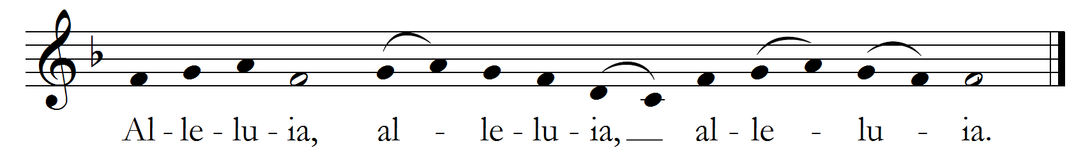

The Holy Gospel: Luke 4:21-30
The Sermon The Reverend Dr. Kate Baird
A period of silence is kept after the sermon.
The Nicene Creed BCP, p. 358
The Prayers of the People, Form III BCP, p. 387
The Confession & Absolution BCP, p. 360
The Peace BCP, p. 360
Welcome & Announcements

The Holy Communion
The Offertory
Choral Anthem Wondrous Love arr. Stephen Sturk
Hymn 304 (stzs 1-4) I come with joy Land of Rest
The Great Thanksgiving: Eucharistic Prayer B BCP, p. 367
Lift up your hearts: Sursum corda S 120
Holy, holy, holy Lord: Sanctus S 125
The Memorial Acclamation S 136
The Great Amen S 142
The Lord’s Prayer S 119
The Breaking of the Bread
The Fraction Anthem: Agnus Dei David Clark Isele
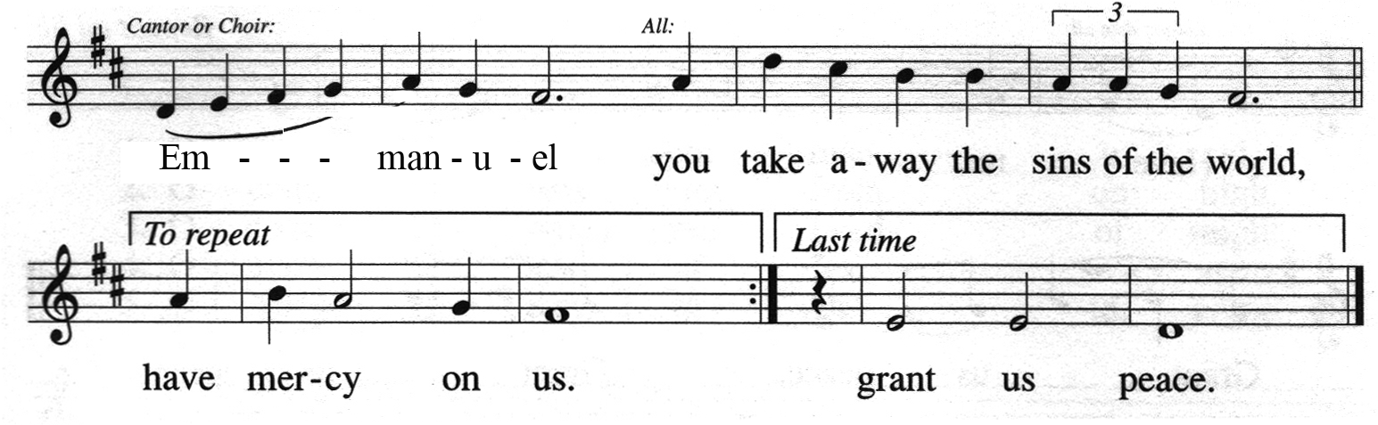
The Communion of the People (If you prefer gluten-free bread, please inform the priest.)
All baptized Christians are welcome to receive Communion. If you are unable to go to the Altar for Communion, please notify an Usher. Communion will be brought to you. If you would like to bring your pet with you to the Communion Rail for a blessing, please do so.
Hymn 448 O love, how deep, how broad, how high Deus tuorum militum
Hymn 312 Strengthen for service, Lord Malabar
The Postcommunion Prayer BCP, p. 366
The Blessing
Hymn 655 O Jesus, I have promised Nyland
The Dismissal BCP, p. 366
Postlude


Meet & greet over refreshments in Julian Hall right after the service.

The Sanctuary Candle is dedicated to the Glory of Almighty God
in loving memory of Anna Buccola–the mother of Jackie Klippert–
on the occasion of her birthday

The Altar Flowers are dedicated to the Glory of Almighty God
in loving memory of Anna Buccola–the mother of Jackie Klippert–
on the occasion of her birthday
LITURGICAL MINISTERS
Ministry | 5:00 pm | 8:00 am | 10:15 am
Celebrant | The Reverend Dr. Kate Baird | The Reverend Dr. Kate Baird | The Reverend Dr. Kate Baird
Preacher | The Reverend Dr. Kate Baird | The Reverend Dr. Kate Baird | The Reverend Dr. Kate Baird
Cantor | -- | -- | Stephen Sturk
Pianist | -- | -- | Wendi Turk
Greeters | Chriss Morrison, Jan Clark | Viki Iredale-Tangas | Cary Klippert, Jackie Klippert
Ushers | Roland Pavlovics | Roland Steele, Chris Junger | Andrea Liesman, Gregg Baker
Chalice Bearers | Judy Pellam, Pete Hicks | Kathy Foxen, Michelle Tangas | Bill Liesman, John Crawford
Acolytes | Pete Hicks, Judy Pellam | Michelle Tangas , Kathy Foxen | John Crawford, Bill Liesman
Lectors | Gina Diamante  Chriss Morrison | Deb Mitchell, Lani Jones | Barry Weiss, Jean Hicks
INTERCESSOR | Chriss Morrison | Lani Jones | Jean Hicks
Altar Guild | Donna Happ | Viki Iredale-Tangas, Lani Jones | Ana Mihok, Jackie Klippert

announcements
An email blast goes out every week with a complete set of announcements. If you do not yet receive this email blast, please send an email to Ruby Arellano— siriusarellano@gmail.com —to let her know what your email address is so you can be added to the list.

- Saint Thomas Bible Challenge – Ongoing monthly – See John Crawford for more information.
- Annual Meeting of the Mission – Today after the 10:15 service
- Rancho Damacitas Birthday Card gifts – Ongoing (see flyer in narthex)
- Benedictine Way – Ongoing, Wednesdays at 7:45 pm after the Healing Service
- Collection of Palm Crosses – Beginning this weekend until Shrove Tuesday, February 9, 2016
- Shrove Tuesday Pancake Supper – February 9, 2016, 7:00 pm
- Ash Wednesday – February 10, 2016, Noon & 7:00 pm
- 4th Annual Sweetheart Car Show – Saturday, February 13, 10:00 am – 2:00 pm

ATTENTION! ATTENTION!
Please place your old palms in the basket in the narthex. These palms will then be burned after the Pancake Supper on Shrove Tuesday, February 9 for Ash Wednesday distribution.


LENT BEGINS ON ASH WEDNESDAY

The liturgical season of Lent begins on Ash Wednesday, February 10th. Lent is the season of forty weekdays that precede Easter Day. This year Easter Day falls on March 27th.
Ash Wednesday is one of the two major fast days in the liturgical calendar. In accordance with ancient custom, on this day the faithful approach the altar on two occasions: first, to receive the imposition of ashes on their foreheads with the words, “Remember that you are dust, and to dust you shall return” and second, to receive the Blessed Sacrament. It is a universal day of penance.
It is a time for us to remember God’s admonition to Adam (Genesis 3:19) “you are dust, and to dust you shall return.” It is a time for us to feel the humility of our humanity. We will commemorate this day with [two separate celebrations of the Holy Eucharist with the Imposition of Ashes: Noon and 7:00 pm.
The liturgical season of Lent dates back to the fourth century of the Common Era. It has its roots in the practice of following the life of Jesus Christ. The synoptic Gospel accounts (Matthew, Mark, and Luke) tell us that after his baptism, Jesus “...was in the wilderness forty days....” It was during this time that Jesus fasted and was tempted by Satan. This time in the wilderness preceded the beginning of Jesus’ ministry in Galilee - it was a time of preparation for Jesus. It is a time of preparation for us, as well. It is a time of penitence, fasting, self-examination, and prayer.

FRIDAYS OF LENT: Devotion, Meal, Reflection, Devotion

On Fridays during Lent, we will observe the devotion of the Stations of the Cross in the church. This is a service that originated with pilgrims to Jerusalem as they made their way to Calvary observing different aspects of Jesus’ passion and death. This special service will begin at 6:30 on Friday evenings.
Meal
Following the service, there will be a Soup & Bread Supper beginning at about 7:00 pm. So as not to violate anyone’s ‘giving up meat’ on Fridays in Lent, we hope to have all of the soup selections be without beef or chicken—fish or shellfish would work fine, as well as vegetarian soups.
Program
After supper, we will spend some time reflecting on the season of Lent using the booklet, Living Well Through Lent 2016: Letting Go With All Your Heart, Soul, Strength, and Mind from Living Compass as a springboard for the evening’s discussion. The booklets are available in the Narthex.

GENTLE REMINDERS

Rancho Damacitas



Young people at Rancho Damacitas are celebrating birthdays this month and every month throughout the year. It is a tradition here at St. Thomas of Canterbury to send a birthday card with a $10 Target gift card to each child. This gift is a special surprise and can lift two spirits-the recipient AND the giver. Are YOU celebrating a birthday, anniversary, or other special occasion this month?
Consider donating a $10 Target gift card to a child at Rancho Damacitas—think of it as a present you give yourself! It’s as easy as picking up a gift card at Target and putting it in the collection plate. Your support is needed and appreciated.

FOOD DONATIONS – PET AND HUMAN


Please don’t forget to donate–as you are able–on the 2nd and 4th Sunday of each month. Pet food is collected on the 2nd Sunday and human food on the 4th Sunday.

Next time you go shopping please add an extra can of food and bring it to church. We are in need of vegetables and fruits in a can, bags of beans, pasta, flour, etc.; non-perishables of any kind are welcome.
God bless you!

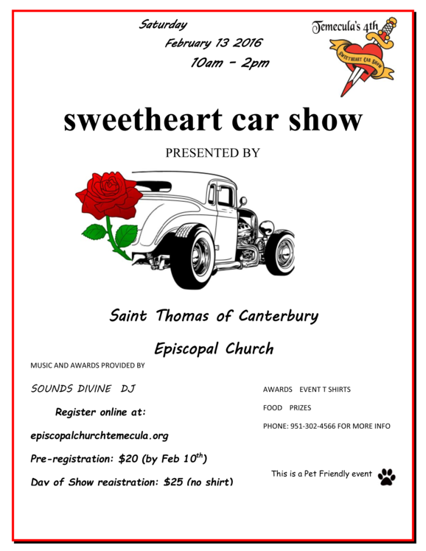



PRAYER LIST
URGENT NEED FOR PET FOOD!

The recent appeal for more
Pet Food donations has resulted in a terrific increase.

Please continue to contribute to the Pet Food ingathering anytime during the month. It gets blessed for distribution on the second Sunday of each month.

Gratefully, Roland Pavlovics, Outreach Coordinator
Saint Thomas of Canterbury Episcopal Church
Temecula, California
We invite you to pray throughout the week with the Daughters of the King for the needs and concerns of our church.
Prayer requests are kept on the prayer list for four weeks. You may renew your request by calling Barbara Bundy.

For the Week of Saturday, January 30 through Friday, February 5, 2016

Entries listed in bold type are new.
The Anglican Cycle of Prayer
Sat: Anglican Church of Central Interior – British Columbia & the Yukon, Canada
Sun: Anglican Church of Burundi & Matana
Mon: Angola – Southern Africa
Tue: Ankole – Uganda
Wed: Antananarivo-Tulear – Indian Ocean
Thu: Antsiranana – Indian Ocean
Fri: Anglican Church in Aotearoa, New Zealand, & Polynesia

The Diocesan Cycle of Prayer
Christ Church, Coronado & for Christ Church Parish Day School

For Our Clergy
Justin, Archbishop of Canterbury
Michael, our Presiding Bishop
James, our own Bishop
Allisyn, our Canon to the Ordinary
Rev’d Dr. Kate Baird, our Supply Priest

For The Nation and all in Authority
Barack, our President
Jerry, our Governor
Jeff, our Mayor

For Those serving in the Armed Forces
Steve McNeil (friend of Faisal Sipra) Michael T. Jordan (grandson of Roberta
Brown)
Drew Durivage (nephew of Jon Floth)
Ryan Conner (grandson-in-law of Kay Bemis) Marc Veale (son of Elizabeth Veale –
preschool teacher)
Taylor Day (grandson of Kay & Ed Rather)
Ryan Longwell (friend of the Tisdales)
Weston Izzi (grandson of the Klipperts)
Tony Valence (friend of Terrie Scheele)

For God’s Peace, Justice, and Mercy
Afghanistan, Syria, Somalia, Israel, Palestine, South Sudan, Ukraine, Iraq,
Sierra Leone, China, Iran, Russia, South Africa, Laos, Mozambique, Myanmar (Burma), Chad, North Korea, The Central Africa Republic, Democratic Republic of Congo, Zimbabwe, France, Yemen, France, Lebanon, Mali

In Thanksgiving For

For Those Suffering: Body, Mind, and Spirit
Tyler Borden (grandson of Janet Bingham)
Mary Lou Ford
Joyce Harnois (sister of Laurie Pratt)
Faith Finklestein (friend of Lani Jones)
Pauline Lifflander
Michael Brown (son of Roberta Brown) Nicholas & his parents, Frank & Connie,
(family of Mary Lou Thomas)
Terri Scheele
Pat MacKenzie
Michael Belcher
Patricia Jeglin (sister-in-law of Roberta Brown)
Doug & Magdalene Merante
Donna Scheele (daughter of Terri Scheele)
Grant Sandy (grandson of friend of Donna
Happ)
Chris Ellison (mother of Patrick Ellison)
Lydia & Mary (friends of Laurie Pratt)
Brian & Lynda Scoles (friends of Judy
Pellam)
John & Connie Priest & family
Chris Junger*
The Carney family & the St. Thomas of Canterbury family *
Diane Pagel (friend of Pat Grannan)
Lilian Menhall & family*
Lani Jones & the Goodall families *
Jim & Sandy Buck (friends of Ron & Paula Tripodi
Jason Phillips (family of Mary Lou Thomas)
Marcella Gross (friend of Lani Jones)
The Hart & Hill & Mandery families*
The Bundy family**
Elaine Colwell (friend of Judy Pellam)
Terry Pellam (daughter-in-law of Judy
Pellam)
Ron & Paula Tripodi *
Laura Palma & family *
St. Thomas of Canterbury family *
Gina Diamante & the Morelli family *
Suzie Grindle**
For A Safe Pregnancy
Katie Bohl (niece of the Tisdales)
Lauren Fox (friend of Laurie Pratt)
Maggie Cabral
Justine Swangler (daughter of Darren & Sonya Jump)
Haleigh Looper (daughter of Darren & Sonya Jump)

For Those Who Have Died
Mildred Junger Earle (aunt of Chris Junger)
Joyce Carney (beloved member of the St. Thomas of Canterbury family)
Audrey Christie (mother of Lilian Menhall)
David Goodall (cousin of Lani Jones)
Jim Hart (uncle of Peter Mandery)
Joan Hill (aunt of Peter Mandery)
Mrs Henry Clyde & Carmine Lombardi (friends of Ron & Paula Tripodi)
Carlos Palma (beloved husband of Laura & beloved member of the St. Thomas of Canterbury family)
Martha Morelli (neighbor of Gina Diamante)

For Those Who are Traveling
Peter Mandery

With Special Intention for

For Our Animals
Midas, 2014 Dogs on Deployment Mascot
Layla (granddog of Mary Lou Thomas)

**For Our Animals Who Have Died
Chloe (beloved pet of the Bundys)
Sunshine (beloved cat of Suzie
Grindle)

January 29, 2016

Church & School: 44651 Avenida de Missiones, Temecula, California 92592
School Office Hours: Monday—Friday; 7:00 am – 6:30 pm
Telephone Numbers: Church (951)302-4566; School (951)302-8498; FAX (951)302-4633
Email Addresses: Church: admin@episcopalchurchtemecula.org
School: Preschool@episcopalchurchtemecula.org
Websites: Church: www.episcopalchurchtemecula.org;
School: www.steptemecula.org.
Thrift Shop: 39825 Alta Murrieta Drive-B3, Murrieta, California 92563
Hours: Sunday: Noon – 5:00 pm; Monday, Wednesday—Saturday: 10:00 am – 5:00 pm;
Tuesday: 10:00 am-7:00 pm
Telephone Number: (951) 600-0043
Email Address: thriftshop@episcopalchurchtemecula.org
Service Schedule:
Saturday: 5:00 pm Holy Eucharist
Sunday: 8:00 am Holy Eucharist
10:15 am Holy Eucharist
Wednesday: 11:00 am All-School Chapel Service
7:00 pm Holy Eucharist with Healing

Jesus Christ Head of the Church
The People of Saint Thomas of Canterbury The Ministers
The Right Reverend James R. Mathes Bishop of San Diego
Vacant Vicar
Peter Mandery (2016)—Christian Education & Property Senior Warden
Keen Haynes (2016)—Stewardship & Property Junior Warden
Brian Hopley (2016)—Finance Treasurer
Barbara Bundy (2016) Clerk of the Bishop’s Committee
Ed Rather (2017)—Stewardship Bishop’s Committee
Cary “Klip” Klippert (2017)—School & Advocacy Bishop’s Committee
Mark Woodruff (2017)—Evangelism Bishop’s Committee
Laura Palma (2016)—Fellowship & Christian Education Bishop’s Committee
Eva Smith (2018)—Servants of God / Outreach Bishop’s Committee
Jack Bundy (2018)—Thrift Shop & Fundraising Bishop’s Committee
Ruby Arellano (2018)—Communication Bishop’s Committee
Vacant November 5, 2016 Convention Delegate
Vacant November 5, 2016 Convention Delegate
Vacant November 5, 2016 Convention Delegate
Vacant November 5, 2016 Convention Delegate
Vacant (Alternate) November 5, 2016 Convention Delegate
Vacant (Alternate) November 5, 2016 Convention Delegate
Vacant (Alternate) November 5, 2016 Convention Delegate
Sharon Eilers Bookkeeper
Barbara Bundy Administrative Assistant to the Vicar
Stephen Sturk, DMA Music Director
Wendi Turk Pianist
Barry Weiss Pianist
Darlene Karnes-Versteegh Preschool Director
Marna Ybarra Thrift Shop Manager

